**ISQS 5350 Unit 2 Homework**

1. (20 points) Compare and contrast the PMBOK generic life cycle (below), the Agile/Scrum approach (Schwalbe section 3-5), and the CDC Unified Process Project Management Guide (shown below). What are their key similarities and differences?

**These three approaches to project management are similarly patterned at a high level, typically progressing through a planning/pre-work phase, an execution phase, and a completion or post-completion phase. The PMBOK generic cycle phases of pre-project work, starting the project, and organizing are similar to the CDC phases of Initiation, Concept, and Planning. Scrum differs from both by mostly focusing on the creation of backlogs (product and sprint) as the pre-project activity.**

**The execution is a single step for PMBOK, while the CDC and Scrum share concepts of iterative development though they are organized differently. The CDC model iterates through the execution phases until it is ready to deliver a final product while Scrum tries to ship increments of the product with every sprint and refine it through later sprints.**

**The generic PMBOK cycle doesn’t include any post-completion steps which is different from both the CDC process and Scrum. The CDC includes both a traditional “maintenance” phase and disposition that ends in a project archive. Scrum ends its sprints with a sprint review and retrospective which considers both improvements to the product and the process itself and tries to incorporate those into future sprints.**

**One feature shared across all processes in some version of review or stage gates. For PMBOK and the CDC, these are strategically placed between phases to ensure the project is prepared up to that point to move forward. Scrum doesn’t call out specific review “gates”, but there are analogous elements in the ceremonies such as the Sprint Planning where assignments are reviewed before the sprint begins. The Sprint Review also functions as a gate at the conclusion of each sprint before work is continued in the next one.**

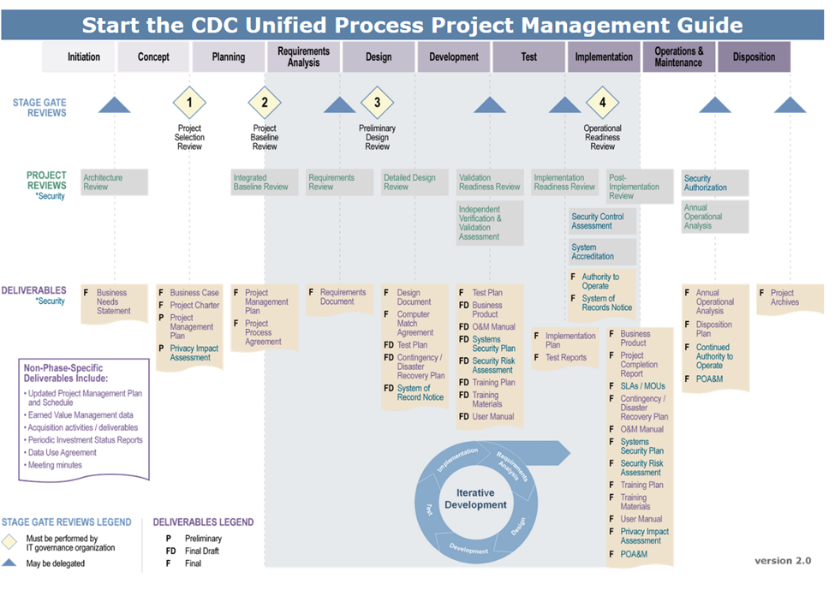

2. (30 points) Compare and contrast the CDC templates for Business Case, Project Charter, and Project Management Plan with their counterparts in the Schwalbe textbook. What are their key similarities and differences?

**The concept of a business case in the CDC Unified Process is related to selecting projects in Schwalbe. The textbook mostly examines the overall view of prioritizing and selecting a project in an organization using techniques like SWOT analysis or value calculations. The CDC business case is specifically used for justifying a particular project so that it can be examined within the broader scope of all projects as objectively as possible. This is likely why it aligns closely to the text, the business case section on business needs would help answer the textbook question of whether it fits within “broad organizational needs.” The alternative analysis in the business case is extremely similar to the net present value (NPV) and return on investment (ROI) analyses of the textbook. Business cases are a little different though, in that they focus on a specific case and how it compares to alternatives that attempt to solve the same problem. Overall project selection is not necessarily looking at just solving a particular problem, but in the projects that provide the most value to the business regardless of specific issues.**

**A project charter serves to kick a project off by outlining basic components and facts of an upcoming project. This helps to inform management as well as define the scope and anticipated use of resources. The CDC model and the Schwalbe text both agree on some of these components: a general overview or statement of work, an outline of the objectives and requirements, a general budget, timelines, and roles and responsibilities for the team assigned to the project. The project charter for the CDC has some additional sections particular to the role of the CDC as a medical and public institution. For example, part of the justification requires a statement of impact to public health and businesses. Also, the budget source must be identified as funding may be specific to a particular project and external stakeholders might be more invested in the outcome.**

**Project management plans define the actual execution of the project, especially areas where stakeholders might be concerned like key milestones and communication plans. Again, the CDC UP plan template shares several similarities with the general textbook description of project management. Elements of this are similar to the project charter, such as project summaries, roles, deliverables, risk management, human resource management, and budgets. Change control management CDC) is a project control that specifically describes how the project will react to unanticipated issues that might arise. There is a detailed schedule in the CDC plan as well which includes milestones, a particular schedule, and even dependencies. For this document, the CDC Unified Process plan tracks very closely to the recommendations from Schwalbe. A few differences that again, might be related to the CDC’s bureaucratic role, are procurement and compliance management. The former ensures that there is a plan to procure additional resources if needed, and the latter specifies the legal processes that the CDC must adhere to. Those legalities may be different than the ones that affect businesses, but there will also be legal issues businesses should consider like Sarbanes-Oxley (SOX) compliance and it is a good idea to include that in the project management plan.**

3. (20 points) On the internet, look up a definition of “user acceptance testing” and “usability testing.” Provide the definitions including what is being measured and when in the project lifecycle it is being measured. Also include the URL. Compare and contrast user acceptance testing, usability testing, and “preprototype user acceptance testing” as defined by Davis & Venkatesh 2004. What are their key similarities and differences?

**The Agile Alliance defines usability testing as “observing a representative end user interacting with the product, given a goal to reach but no specific instructions for using the product.”** [1] **How the user interacts with the product is recorded and examined later to understand any challenges or unexpected behavior.**

**The International Software Testing Qualifications Board (ISTQB) publishes a glossary of testing terms. The ISTQB’s definition of user acceptance testing is “formal testing with respect to user needs, requirements, and business processes conducted to determine whether or not a system satisfies the acceptance criteria and to enable the user, customers or other authorized entity to determine whether or not to accept the system.”** [2]

**Both of these testing types are concerned with how users will interact with an IT product after it is developed. This is reinforced by the traditional SDLC model that would have both UAT and usability testing performed in the “testing” phase which importantly is after the product has been planned, defined, designed, and built.**

**In “Toward Preprototype User Acceptance Testing of New Information Systems: Implications for Software Project Management” authors Fred Davis and Viswanath Venkatesh propose a process by which “user acceptance testing may be done much earlier in the system development process than has traditionally been the case.”** [3] **This process is referred to as “preprototype user acceptance testing” which refers to UAT performed on an IT product before the prototype has been developed. Specifically, Davis and Venkatesh’s research suggests that the only general information about the intended functionality of a system is necessary to perform accurate testing.**

**Compared to general UAT and acceptance tests, preprototype UAT could be performed much earlier in the development lifecycle. This is important because the amount of invested resources increases with progress in the lifecycle. If a system could be tested in the design or even analysis phase, the likelihood of project failure could be determined much earlier which would allow either adjustments to the project design or ending it altogether at a more opportune time. Given the cost and frequency of failed IT projects, it would be extremely valuable to implement preprototype UAT in any development process used by an organization.**

4. (20 points) Identify the testing procedures within the CDC Unified Process Project Management Guide (<https://www2a.cdc.gov/cdcup/library/pmg/frame_page.htm> ) and the Schwalbe textbook that are most similar to preprototype user acceptance testing. What are their key similarities and differences?

**User Acceptance Testing is included in the “Performing” tests section of the CDC UP guide. Like the textbook, the CDC is mostly concerned with having extensive test plans written for a battery of tests after development. They do concede, however, that “informal testing may be performed by developers, quality assurance, users, etc.” Informal user tests are helpful, but formalized preprototype user acceptance tests early in the process are likely more useful for obtaining perceived usefulness and ease of use that can identify system issues early.**

5. (10 points) Where within the PMBOK generic lifecycle (above), the Agile/Scrum approach, and CDC Unified Process (above) would you recommend assessing the user acceptance of a system based on the technology acceptance model?

**The technology acceptance model suggests that perceived usefulness is more important than perceived ease-of-use. Typically, the former will be known much earlier in the development process than ease-of-use which may require some understanding of the interface to ascertain. For both the CDC UP and PMBOK methods, the usefulness can be determined as early as the Planning phase so I would recommend conducting UAT at that point. For Scrum this is a little tricky as the project phases are shorter and there isn’t much time to do any time of testing outside of the sprint. What I would recommend is having a sprint dedicated to designing and performing the preprototype UAT before design or building begins. In this way your “shippable product” is the test itself with your team and management as the stakeholders. You could also have the product owner perform the testing outside of the sprint, as they are responsible for determining the value of a product in the backlog.**

# Works Cited

|  |  |
| --- | --- |
| [1] | Agile Alliance, "Usability Testing," [Online]. Available: https://www.agilealliance.org/glossary/usability/. [Accessed 19 07 2020]. |
| [2] | International Software Testing Qualifications Board, "Standard Glossary of Terms used in Software Testing," 2018. [Online]. Available: https://astqb.org/assets/documents/ISTQB-Glossary-3.2-terms-used-in-FL2018.pdf. [Accessed 19 07 2020]. |
| [3] | F. D. Davis and V. Venkatesh, "Toward Preprototype User Acceptance Testing of New Information Systems: Implications for Software Project Management," *IEEE Transactions on Engineering Management,* vol. 51, no. 1, pp. 31-36, 2004. |